**TOWN OF STAR CITY**

[](http://www.google.ca/url?sa=i&rct=j&q=&esrc=s&source=images&cd=&cad=rja&uact=8&ved=0ahUKEwjCv7b5wfLJAhVro4MKHYb7ABAQjRwIBw&url=http://eachieveacademy.blogspot.com/2015/01/student-council-newsletter-january-2015.html&bvm=bv.110151844,d.amc&psig=AFQjCNFQGjiLBk19aGxXOpMT91CTEjgEmw&ust=1450978402426651)

**2017 NEWSLETTER**

**PARKING ON THE STREETS DURING THE WINTER MONTHS …**

PLEASE ENSURE YOUR MOVING YOUR VEHICALS AT LEAST EVERY 48 HOURS SO WE CAN DO OUR BEST TO GRADE THE STREETS.

**THANK YOU!**

2

0

1

7

**HAPPY NEW YEAR!**

All the best in 2017

From the Town of Star City, Mayor, Council & Staff

Council Meetings will be on the 2nd

Monday of each month

Next council meeting is Jan. 9th @ 7pm

[](https://www.bing.com/images/search?q=VOVO+grader+in+snow+clipart&view=detailv2&&id=B35DE6001EFD95F2A33A33E183F1D5F26F39BA5F&selectedIndex=21&ccid=dDnfcWtz&simid=608021891274637406&thid=OIP.dDnfcWtzWw_KfsoBBMqexgEsDD)

**Just a Reminder that Dog & Cat Licences expired December 31st, 2016. Pet licences are to be renewed before January 31st, 2017**

**CASTRATED/SPAYED … $15.00**

**NON-CASTRATED/SPAYED … $ 20.00**

**RESTRICTED DOG … $50.00**

**THIS PRICE IS IN EFFECT UNTIL JAN.31** AT WHICH TIME THE COST OF THE TAG DOUBLES. IF YOU HAVE ANY QUESTIONS ABOUT THE NEW BYLAW PLEASE CONTACT THE TOWN OFFICE.

**REMINDER:**

**Please remember to check your garden hoses and to shut off any outside taps to prevent any water breaks over the winter months.**

**Thank you.**

PLEASE SHOW CONSIDERATION OF YOUR NEIGHBORS WHEN REMOVING SNOW FROM YOUR YARD. DO NOT PUSH/BLOW YOUR SNOW INTO OTHERS’ YARDS. THANK YOU.

**CONGRATUALTIONS TO OUR 2016 STAR CITY CITIZEN OF THE YEAR:**

**FAY TYACKE**

[](https://www.google.ca/url?sa=i&rct=j&q=&esrc=s&source=images&cd=&cad=rja&uact=8&ved=0ahUKEwiM3Y-Yw7jJAhXH2D4KHZpOD-sQjRwIBw&url=https://sites.google.com/site/sidneysnowshoveling&psig=AFQjCNHngXJuCehiQxpReoUeYSEoXEIBWA&ust=1448985849411444)

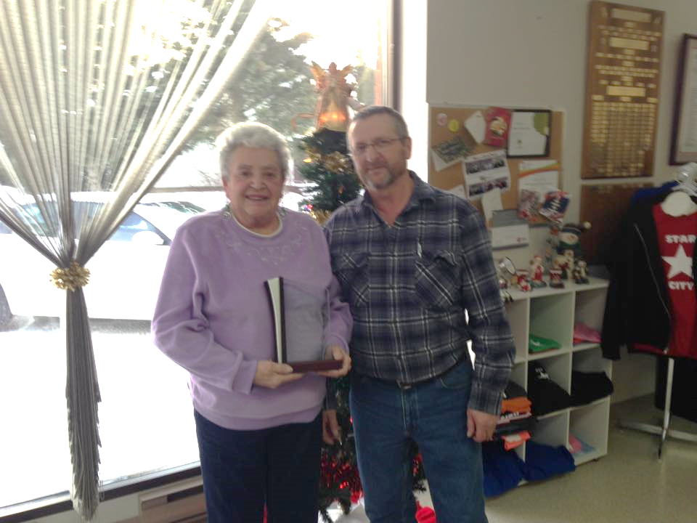

**Fay would like to send out a big Thank you for all the Congratulations and would also like to thank the people who nominated her for 2016 Star City Citizen of the Year.**

**It is very much appreciated.**

**Photo: Mayor Ron Campbell (right) presenting 2016 Citizen of the Year Award to Fay Tyacke (left)**

**STAR CITY LEGION**

BUILDING REPAIR FUNDRAISER

**FISH FRY**

BAKED POTATOES, BEANS, COLESLAW AND DESSERT

$10.00

**WEDNESDAY, JANUARY 11TH**

**5:30 -7:30**

EVERYONE WELCOME

**STAR CITY LIBRARY NEWS ….**

WINNER OF THE CHRISTMAS BAKING DRAW WAS WON BY FAY TYACKE. THE DRAW WAS MADE BYCREEDENCE CAMPBELL.

THE LIBRARY WOULD REALLY APPECIATE IF MORE PEOPLE FROM THE COMMUNITY WOULD COME IN AND USE THEIR SERVICES OF FREE INTERNET, BOOKS & DVD’S. THE CIRCULATION IS GOING DOWN, AND THE LIBRARY HAS ALREADY PURCHASED 2 HOURS TO STAY AT 16 HOURS/WEEK. THE LIBRARY WILL LOSE MORE HOURS IF THE CIRCULATION CONTINUES TO DROP. IF ANYONE HAS IDEAS ON ANY PROGRAMS THEY ARE WELCOME TO CONTACT THE LIBRARY. PLEASE SHOW YOUR SUPPORT SO WE DON’T LOSE OUR LIBRARY!

STAR CITY LIBRARY … 306.863.4364



**MISSION 2017**

**PRAIRIE WOMEN ON SNOWMOBILES**

**FUNDRAISING BANQUET**

**FOR BREAST CANCER RESEARCH**

FRIDAY, FEBRUARY 3RD, 2017

BANQUET TICKETS - $25.00

COCKTAILS: 6:00PM & SUPPER: 7:00PM

TICKETS AVAILABLE AT:

SCOTIA BANK IN MELFORT,

STAR CITY TOWN OFFICE OR BY PHONING:

DEBBIE PERKINS: 306.863.2626

KEVIN BLAIR: 306.921.7084

CANDY BLAIR: 306.921.8295

PRESENTED BY THE STAR CITY NITE RIDERS

WINTER FOOD HAMPERS

IF YOU WISH TO RECEIVE A FOOD HAMPER, FOR PICK UP OR DELIVERY PLEASE CONTACT REV. CAROLE OR REV. CHARLES @ 863.2999

BY JANUARY 13TH

OR, LEAVE A PHONE MESSAGE WITH YOUR NAME & PHONE NUMBER. THANK YOU.

FOR A FOOD EMERGENCY AT ANYTIME CONTACT REV. CHARLES OR REV. CAROLE

OFFERED BY THE STAR CITY UNITED CHURCH





**Star City Elks**

**12th Annual**

**Steak Supper & Auction**

**March 11th, 2017**

**@ The Star City Elks Hall**

**Star City Lodge Contact Persons:**

Shawn Mooney: 863-4131 Neil Perkins: 863-4273

Luke Perkins: 863-4131 Norm Palmer: 863-2783

Kris Wingert: 863-2512 Marvin Jansen: 863-4445

Lloyd Rutherford: 873-2435 Rod Englund: 863-2302



**CURFEW BYLAW:**

Children under the age of 16 are no longer allowed out after 11:00 pm unless with a parent or guardian. The Curfew Bylaw will be forwarded to the RCMP and they will be enforcing it.

If you have any questions please contact the Town Office.



**TOWN OFFICE HOURS**

**Monday – Friday 8:00 AM – 4:30 PM**

**CLOSED FROM 12:00 – 12:30 FOR LUNCH**

**VISIT OUR WEBSITE @ TOWNOFSTARCITY.COM**