

**TOWN OF STAR CITY**

**AUGUST NEWSLETTER**

**NOTICE:**

**There will be no Council Meeting in the month of August. The next Council Meeting will be in September.**

**NOTICE:**

**2015 AUDITED FINANCIAL STATEMENT**

PURSUANT TO SECTION 185 (3) OF **THE MUNICIPALITIES ACT** NOTICE IS HEREBY GIVEN TO ADVISE THAT THE 2015 AUDITED FINANCIAL STATEMENT FOR THE TOWN OF STAR CITY IS AVAILABLE FOR VIEWING AT THE TOWN OFFICE DURING REGULAR OFFICE HOURS (MONDAY TO FRIDAY 8:00 AM TO 4:30 PM)

**JULY WATER BILLS ARE AN ESTIMATE READ. ACTUAL METER READS WILL BE DONE AGAIN FOR AUGUST BILLING**.

**ELECTION!!**

Do you want to shape our community? The Municipal Election is being held on October 26. In September, more information will be provided regarding nominations so watch for details. So as you enjoy the last month of summer, consider running for public office!

**ARE YOU INTRESTED IN HAVING A HOMECOMING IN 2017? …**

**THEN WE NEED YOUR HELP!**

IF YOU ARE INTRESTED IN HELPING/PLANNING FOR A 2017 HOMECOMING PLEASE CONTACT THE TOWN OFFICE @ 863-2282 AS WE NEED TO GET THINGS STARTED SOON … THANK YOU!







**ATTENTION TO ALL RESIDENTS:**

A BLACK BEAR WAS SPOTTED ON JULY 17TH NEAR THE OUTSKIRTS OF TOWN (LOVER’S LANE). CONSERVATIONS OFFICERS HAVE BEEN CONTACTED & ADVISE EVERYONE TO MAKE SURE ALL YOUR GARBAGE IS PUT INTO GARABE CANS WITH TIGHTLY SECURED LIDS SO IT DOES NOT ATTRACTING WILDLIFE INTO TOWN LIMITS. BEARS ALSO LIKE BOWLS OF DOG/CAT FOOD THAT IS LEFT OUT IN YARDS SO PLEASE KEEP IT IN A SAFE LOCATION & NOT OUT IN THE OPEN.

IF YOU DO SPOT A BEAR IN OR NEAR TOWN, PLEASE KEEP YOUR DISTANCE AND CONTACT LUKE PERKINS @ 306-921-3226 OR THE 24 HOUR HOTLINE @ 1-800-667-7561.

**CONSERVE WATER**

With the recent water advisory due to the Husky Oil spill, ***RESIDENTS ARE STRONGLY URGED TO CONSERVE WATER***. We ask for the time being that all non-essential water usage cease. This includes but not limited to

* Filling of swimming pools, hot tubs, fountain spas or other outdoor water features
* Washing of automobiles, trucks, sidewalks, driveways
* Watering of lawns (including sod) and gardens.





**TAKE PRIDE IN OUR COMMUNITY & KEEP IT CLEAN.**

**PLEASE DO YOUR PART AND KEEP YOUR YARD**

**‘JUNK’ FREE. THANK YOU!**

**THANK YOU**



**Star City Summer**

**Playground Program**

**July & August**

2:00pm – 4:00pm

@ Star City Skating Rink

The program will run Tuesday’s & Thursday’s for children between the ages of 5-12

**Star City Library TD Summer**

**Reading Draw**

To enter kids must be 14 years of age and younger.

For every 8 items taken out you will receive an entry from to fill out.

Entry forms will have to be in no later than August 29th & the draw will take place on Monday September 12th.

Some Prizes that are included are: ASUS ZenPad S8.0 tablet and assorted books!

**Good Luck & Happy Reading!**

**PLEASE REMEMBER TO**

**SLOW DOWN & WATCH**

**FOR KIDS AT PLAY**





**Prairie Women on Snowmobiles Inc.**

**GOLFING FOR BREAST BUDDIES**

**To raise Awareness for Breast Cancer Research**

**SUNDAY AUGUST 14TH 2016**

**Melfort Golf & Country Club**

**In Support of The Prairie Women on Snowmobiles**

**– LOCAL RIDER: CANDY BLAIR**

**PROCEEDS GOING TO MISSION 2017**





**Hole-in-One Prize:**

**Choice of a**

**or**

**Snowmobile!**

THURSDAY, AUGUST 4TH

**“PICK UP” BALL** FOR

ALL AGES & SKILL LEVELS

6:00 PM AT THE SPORTS GROUNDS

FOR MORE INFORMATION, PLEASE CALL BUD SPENCER @ 863-4381

*9-hole Scramble & Supper

*Putting Contest

*Silent Auction

*50/50

Image result for yamaha logo



**\*Gunshot Start 1pm**

**\*Supper 5:30**

**\*Space is limited – register early**

**\*Golf & Supper: $50.00**

**\*Supper only: $20.00**

**\*Registration Deadline:**

**Monday, August 8, 2016**

**\*Call the Melfort Golf & Country Club**

**to register: 306-752-3279**

**\*Supper tickets available at the**

**Melfort Golf & Country Club or by**

**calling Kevin: 306-921-7084 or**

**Candy: 306-921-8295**

**Hole-in-One Sponsor:**

Kevin Blair Welding Services

**Snowmobiles provided by:**







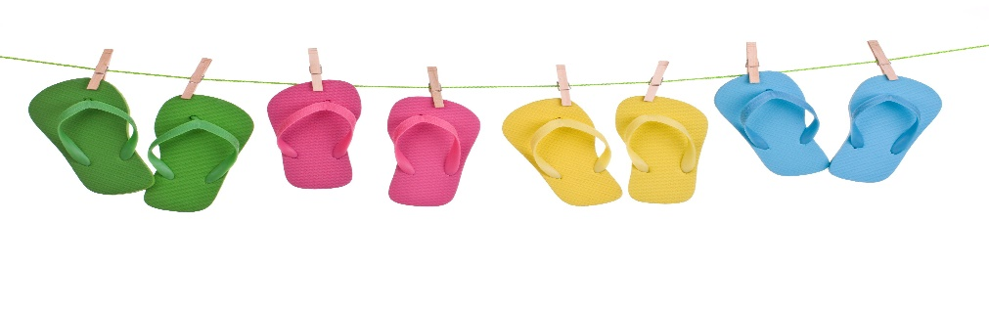

[](http://www.google.ca/url?sa=i&rct=j&q=&esrc=s&source=images&cd=&cad=rja&uact=8&ved=0ahUKEwjkmp6wu4nMAhWLSRoKHVOPAYIQjRwIBw&url=http://www.useconference.com/&bvm=bv.119028448,d.ZWU&psig=AFQjCNEGO01ykibVnY8lo2HipmI1aqpBlw&ust=1460562997190122)

**Star City Library Hours**

**Monday – 5:30 pm to 8:30 pm**

**Tuesday – 1:00 pm to 5:30 pm**

**Wednesday – 9:00 am – 1:00 pm**

**Thursday – 1:00pm – 5:30 pm**

**TOWN OFFICE HOURS:**

Monday – Friday 8:00 AM – 4:30 PM

CLOSED FROM 12:00 – 12:30 FOR LUNCH

**VISIT OUR WEBSITE @ WWW.TOWNOFSTARCITY.COM**