

**TOWN OF STAR CITY**

**2018 NEWSLETTER**

**September**

Next Council Meeting

will be held September 10th

at the Town Office @ 7:00 pm.

**NEW GREENLAND WASTE**

**GARBAGE PICK UP & RECYCLE PROGRAM**

**GARBAGE SCHEDULE: RECYCLESCHEDULE:**

SEPTEMBER 3RD  SEPTEMBER 10TH

SEPTEMBER 17TH SEPTEMBER 24TH

**Please make sure to wheel your carts out to the street, lids closed, away from parked vehicles and wheels towards the curb or boulevard depending on where you live.**

**For a complete list of things to recycle, please come to the Town Office and pick up a Greenland Waste pamphlet or visit greenlandwaste.ca**

**Please note that putting waste in any other dumpster other than your own is prohibited and**

**penalties will apply.**

**Commercial Recycling Bins have also been placed beside the Curling Rink for residents needing to recycle bigger pieces of cardboard, etc.**

**Please contact the Town Office if you have any questions @ 306.863.2282**

**\*\*ATTENTION: MONDAYS WILL BE THE NEW DAY FOR COMPOST & TREE PICK UP\*\***

Compost bags are available at the Town Office free of charge to residents for grass clippings, leaves, pinecones, garden scraps etc. Please leave them near the back alley for pick up.

**TREE BRANCHES**

Just a friendly reminder that when trimming trees in your yard, please stack them on the boulevard or near the alley, piled parallel to the road,

no more than 8-10 ft. lengths

**NOTE: IF BRANCHES ARE NOT NEATLY PILED OR ARE TOO BIG TO BE PICKED UP BY OUR PUBLIC WORKS EMPLOYEES, CHARGES MAY BE APPLIED.**

**NEW WATER METER READERS**

THE TOWN WILL BE INSTALLING NEW WATER METER HEADS IN EVERY HOME THROUGHOUT THE MONTH OF SEPTEMBER. IT’S ONE OF THE FIRST STEPS TO OUR NEW WATER READ UPDATE SYSTEM – AND WE’RE EXCITED!

PLEASE MAKE SURE YOUR WATER METER IS EASLIY ACCESSABLE.

**Notice of Abandonment of Poll**

Whereas a poll is not required to The Local Government Election Act for the office(s) of:

Councillor: TOWN OF STAR CITY (3)

I hereby give public notice that no voting for the said office(s) will take place and the following persons are elected by acclamation:

Councillors: Charles Boulanger

Nicole Grout

Nick Koturbash

Dated at Star City, this 31st day of August, 2018

Anita Tkachuk

Returning Officer

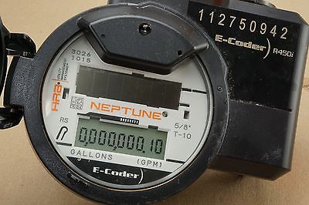

**STAR CITY SKATING RINK NEWS**

The Town of Star City will be taking over the Skating Rink for the 2018/2019 season. To book ice time or schedule an event please contact the Town Office at 306.863.2282 during regular business hours

Monday – Friday 8:00am – 4:30pm





**Star City Public Library Hours:**

Monday – 5:30pm – 8:30pm

Tuesday – 1:00pm – 5:00pm

Wednesday – 9:00am – 12:00pm

Thursday – 1:00pm – 5:00pm

**Ph. # 306-863-4364**

Star City School Grade 1 - 12 Start back on Tuesday September 4th and Kindgarten on Wednesday, September 5th



[](http://www.google.ca/url?sa=i&rct=j&q=&esrc=s&source=images&cd=&cad=rja&uact=8&ved=0CAcQjRxqFQoTCP32q6KM1scCFUgXPgodZ84Ktw&url=http://www.luxeknows.com/blog/page/2/&ei=z7zlVb3TNciu-AHnnKu4Cw&psig=AFQjCNFKf5C2_FQUaLt9-SmUSHBo7dYI-w&ust=1441205820344241)

**As the children return to the school year, Please remember to SLOW DOWN IN & AROUND THE SCHOOL ZONES.**

Sunday, September 9th is



National Grandparents Day is observed on the first Sunday of September each year. The day honors grandparents and their role in helping our families and communities.



Fun Days in September:

* Sept 5th – National Cheese Pizza Day
* Sept 9th – National Teddy Bear Day
* Sept 10th – Swap Ideas Day
* Sept 14th – Hug your Hound Day
* Sept 16th – National Play-Doh Day
* Sept 18th – Rice Krispy Treat Day
* Sept 19th – National Talk like a Pirate Day
* Sept 28th – Good Neighbor Day

**First Day of**

**Fall is**

**Septemer 22nd**

“By all these lovely tokens September days are here,   
with summers best of weather and autumn's best of cheer”

~ Unknown author

**TOWN OFFICE HOURS**

**Monday – Friday 8:00 AM – 4:30 PM**

**CLOSED FROM 12:00 – 12:30 FOR LUNCH**



**The Family Fun Day Committee & Town of Star City would like to say THANKS...**

* **Thanks** to the Fire Brigade for putting on a great Pancake Breakfast
* **Thanks** to On the Fly for a great afternoon of sweet treats & bouncy castles
* **Thanks** to Brian & Michelle Syniuk & Terry Tkachuk for their donations of generators to run the bouncy castles for the afternoon
* **Thanks** to Carla Wilson & Terry Kinequon for the food booth at the Sports Grounds ~ that was some great corn on the cob!
* **Thanks**  to Star City Communities in Bloom for the donation of the sand toys, tattoo & bubble stations and the volleyball
* **Thanks** to Harry Tkachuk & the Toe Tappers for a ‘Toe Tapping’” good time at the Old Time Dance
* **Thanks** to Cheryl O ’Flannagin & the O’ the Taste team for an excellent Pig Roast Supper
* **Thanks** to Llewelyn Moss with local performers Michael Tkachuk & Terry Tkachuk for a Rockin’ GREAT Night
* **Thanks** to the O’ Flanningans & their little local helper/performer Jackman Spencer – great job!
* **Thanks** to Tanner Petrie – a hometown guy who is always good entertainment
* **Thanks** to Brent Sutton & Brian Syniuk for their donation of trailers used for the stage for our performers
* **Thanks** to the Star City Elks for putting on the Beer Gardens ~ Cheers!
* **Thanks** to Clearwater Dugout Services for providing the midnight lunch
* **Thanks** to the Town of Star City & the Family Fun Day Organizing Committee for bringing it all together
* **Thanks** for everyone who came out and made our Family Fun Day & Rockin’ Night a success!
* And if we have forgotten anyone (which is bound to happen with all the hustle and bustle) …

**THANKS TO YOU TOO !!**

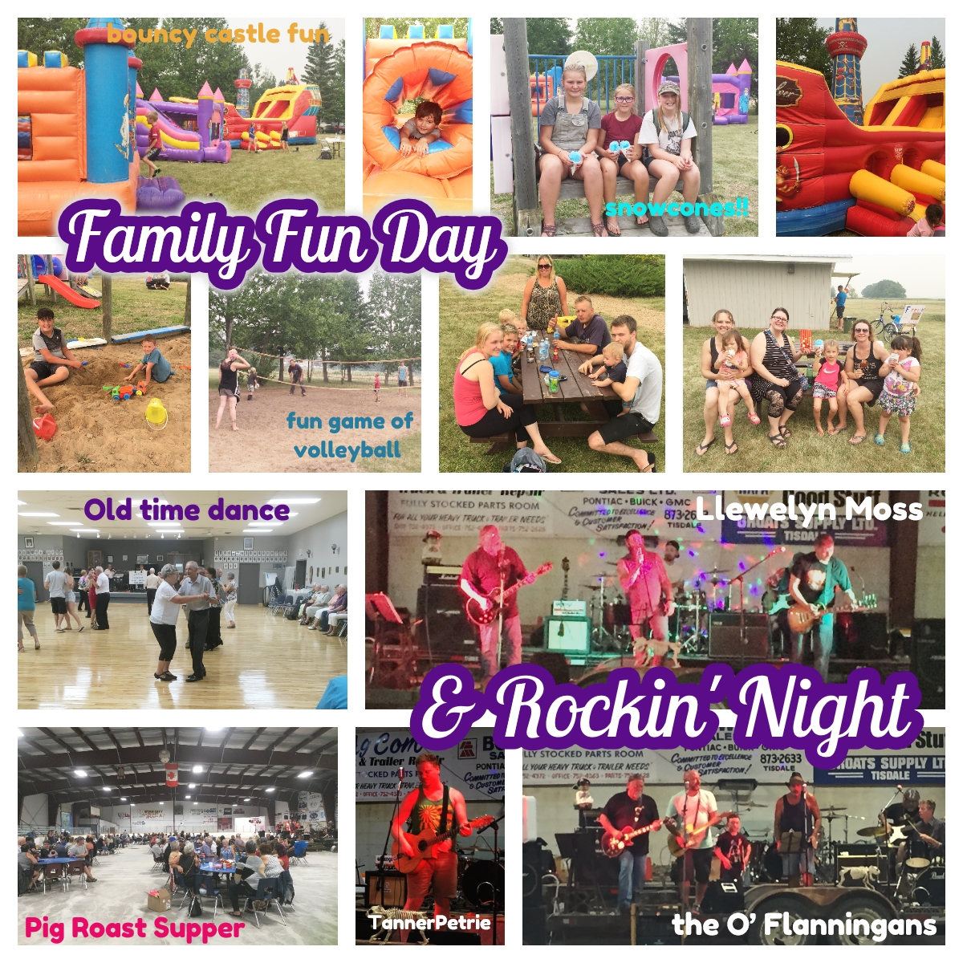





**Hey Star City!! …**

**It’s Time for some Community Spirit!**



**STAR CITY SCARECROW CONTEST**

Have you always wanted to create your very own scarecrow?

Here's a chance to let your imagination run wild,

and compete for fun prizes in the process.

There is **NO** entry fee, and you can use supplies scavenged from around the yard or storage shed. Borrow Grandpa's old straw hat, maybe Grandma’s old apron… even the dog’s bandana

… just be sure to ask first! Your scarecrow must live within Town limits of Star City to qualify … **ALL AGES WELCOME TO PARTICIPATE!**

* **Entry deadline will be September 24th**
* **Online Judging will take place between Sept.26th – October 8th**
* **Winners will be announced October 10th**

To enter your scarecrow, please contact the Town Office by phone, email or in person. We will then come take a photo and place it on our Facebook page for judging. Don’t use Facebook? We will also have the photos on our Town’s Web page www.townofstarcity.com for viewing and you may email your vote for your favorite scarecrow by email to: [town.starcity@sasktel.net](mailto:town.starcity@sasktel.net)

Please contact the Town Office if you have any questions @ 306.863.2282

HAVE FUN!!

