**TOWN OF STAR CITY**

**2017 NEWSLETTER**

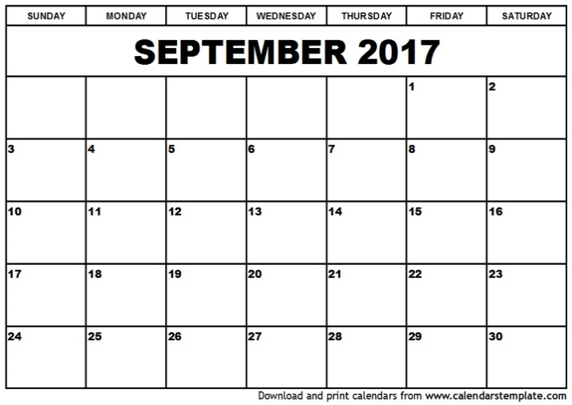[](http://www.google.ca/url?sa=i&rct=j&q=&esrc=s&source=images&cd=&cad=rja&uact=8&ved=0CAcQjRxqFQoTCISr9_qTyscCFQ9Mkgod0LkKyA&url=http://www.clipartbest.com/town-council-clipart&ei=Q3rfVcT9M4-YyQTQ86rADA&psig=AFQjCNGzCyV2sS7MB7cNMb3Ox2mzMi6DRw&ust=1440795573594443)

**NOTICE:**

Next council meeting is

Wednesday, October 11th @ 7:00pm

The office will be closed on Monday, October 9th, 2017

**ATTENTION!!**

**PLEASE CHECK THE WEIGHT OF YOUR GARAGE WHEN YOU PUT IT INTO YOUR GARABE CONTAINERS … IF IT TOO HEAVY, THE TOWN EMPLOYEES WILL NOT PICK IT UP.**

**ALSO MAKE SURE ALL GARBAGE BAGS ARE PUT INTO A CONTAINER WITH A CLOSE FITTING LID TO AVOID CRITTERS FROM GETTING INTO THEM AND SPREADING THE GARBAGE AROUND TOWN.**

**THANK YOU!**

[](https://www.bing.com/images/search?q=Thanksgiving+Graphics&view=detailv2&&id=A2FB3A78F394D01ADAB6710149B7819E72116AD6&selectedIndex=98&ccid=A7z6JiSf&simid=608023974204538934&thid=OIP.M03bcfa26249fa749e57a18782f638195o0)

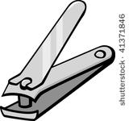

**STAR CITY WELLNESS CLINIC**

**AT STAR COURT**

4TH WEDNESDAY OF EVERY MONTH

OCT. 25TH 9-10AM

NOV. 22ND 9-10AM

** NO CLINIC IN DECEMBER**

Please use Main Entrance.

**EVERYONE WELCOME.**



**Library Week is**

**October 16th – 22nd**

The Library will have refreshments from 2-4 on Tuesday, October 17th

Drop in and enter a draw while you pick up

a book or movie

**October 1st – 7th is Senior’s Week**

**Drop in at the Library for coffee on Tuesday, October 3rd from 2pm-4pm**





**Halloween is on Tuesday, October 31st**

**PLEASE MAKE SURE TO SLOW DOWN AND**

**WATCH FOR THE KIDS OUT TRICK OR TREATING.**



[](https://www.bing.com/images/search?view=detailV2&ccid=aqpaA2Qw&id=329DB66A4AF2BB6C270D1D7242010970BC2C471B&thid=OIP.aqpaA2QwQaT-_ToUTQ8HKQEsDU&q=turkey+dinner+clipart&simid=608041025830650644&selectedIndex=0)[](http://www.google.ca/url?sa=i&rct=j&q=&esrc=s&source=images&cd=&cad=rja&uact=8&ved=0CAcQjRxqFQoTCJXsuNDs1scCFYhYPgodG2ACXg&url=http://www.clipartsheep.com/red-fall-leaf-clipart/dT1hSFIwY0RvdkwzZDNkeTVqYkd0bGNpNWpiMjB2WTJ4cGNHRnlkSE12ZGk5V0wwb3ZTUzkwTDIwdmNtVmtMV3hsWVdZdGFHa3VjRzVufHc9NDYyfGg9NTk2fHQ9cG5nfA/&bvm=bv.101800829,d.aWw&psig=AFQjCNHwT1BpFTNFkIAooHpjJ1J5buIpnw&ust=1441231700511062)

**Star City United Church**

**Star City Travel Club**

**Fall Supper**

**at the Star City Elks Hall**

**Sunday, October 29th**

**4:30 – 6:30**

**Turkey/ham**

**Perogies, cabbage rolls, salad & all the trimmings**

**Pie/dessert**

**Adults $15.00**

**7-12 years $8.00**

**3-6 years $4.00**

**Family $48.00**

The Star City Before & After School Program needs board members. Anyone interested, please call Layla @ 306.921.9349

**STAR CITY SCHOOL NEWS …**

**Education Week – October 16th – 20th**

**“Building our Future by Learning Together”**

*The School will celebrate Education Week with the following activities:*

**Monday,** October 16 - free pancake & sausage breakfast for all students

**Tuesday**, October 17 – Buddy Reading time for Kindergarten - Grade 9 students

**Wednesday**, October 18 – Terry Fox Run

**Thursday**, October 19 – School Pictures @ 9:00 am – preschoolers are welcome to come at 8:45

**Friday,** October 20 – Pajama Day

**NO SCHOOL: OCTOBER 2ND OR OCTOBER 9TH**





**Rummage Sale**

“New to You Special Treasures”

At the Star City United Church

**Wednesday, October 11th – 1pm to 8pm**

**Thursday, October 12th – 9am – 12 noon**

** If you have items you would like to donate, the church will be accepting them October 11th from 9am – 12 noon, or anytime sooner

**Star City School is once again partnering with Melody Motors in Melfort for the WE Scare Hunger Campaign.  The school will be collecting non-perishable food items October 3-31 to donate to local food banks.  Students, parents and community members may drop off donations any time between Oct. 3 -31.  Last year we collected 310 lbs. of food, let’s see if we can break that total! Thank you for your support of this project to help those less fortunate.**

**Star City School Fall Supper**

**Thursday, October 19th**

**5:00pm – 7:00pm**

In the Star City School Gymnasium

(Baked ham, baked potatoes with all the fixing’s, hot vegetable, variety of salads, buns and homemade pie for dessert)

3 & Under – Free

Ages 4 – 9 - $5.00

Ages 9 & up - $10.00



**Star City Service Winter Hours**

Starting 0ctober 2nd – April 1st

8:00am – 8:00pm

[](https://www.google.ca/url?sa=i&rct=j&q=&esrc=s&source=images&cd=&cad=rja&uact=8&ved=0CAcQjRxqFQoTCJGmhqSVmsgCFZYZkgodUYMBUQ&url=https://www.pinterest.com/sweetmarlo/fall-clipart/&psig=AFQjCNEhXklE2pIUTyVP719XADQi5WgYgQ&ust=1443544546154450)



**TOWN OFFICE HOURS**

**Monday – Friday 8:00 AM – 4:30 PM**

**CLOSED FROM 12:00 – 12:30 FOR LUNCH**

**VISIT OUR WEBSITE @ TOWNOFSTARCITY.COM**