**TOWN OF STAR CITY**

**2016 NEWSLETTER**

**NOTICE:**

**2015 AUDITED FINANCIAL STATEMENT**

PURSUANT TO SECTION 185 (3) OF **THE MUNICIPALITIES ACT** NOTICE IS HEREBY GIVEN TO ADVISE THAT THE 2015 AUDITED FINANCIAL STATEMENT FOR THE TOWN OF STAR CITY IS AVAILABLE FOR VIEWING AT THE TOWN OFFICE DURING REGULAR OFFICE HOURS (MONDAY TO FRIDAY 8:00 AM TO 4:30 PM)

**NOTICE:**

Next council meeting is

Monday, July 25th at 7:00pm

[](http://www.google.ca/url?sa=i&rct=j&q=&esrc=s&source=images&cd=&cad=rja&uact=8&ved=0ahUKEwjfvN2W_pXLAhUEXD4KHU3vD0wQjRwIBw&url=http://www.dresskinh.tk/wall/clip-art-staff-meeting/&bvm=bv.115339255,d.cWw&psig=AFQjCNEGIZL-ONP41jAaVSY7RrORI8dLrg&ust=1456595129458558)

**A BIG THANK YOU! to all of you at CITY SERVICE for your years of service as well as all of your involvement in the community**.

**& WELCOME to the NEW OWNERS of STAR CITY SERVICE!**

NEW BYLAW OFFICER!!

The Town of Star City has enlisted the services of B & B enforcement services. He will be enforcing Town Bylaws & will be easily identifiable. He will be starting in a few weeks.



**ATTENTION!!**

**IN CASE OF CANADA POST LABOUR STOPPAGE, TAX NOTICES WILL BE PROCESSED & AVAILABLE FOR PICK UP AT THE TOWN OFFICE BEGINNING JULY 15TH, 2016**





Image result for canada post logo

**JUST A REMINDER …**

**IF YOU PLAN ON BUILDING A FENCE, DECK, GARAGE, ETC. THIS SUMMER PLEASE STOP IN THE TOWN OFFICE TO SEE ABOUT THE GUIDELINES AND IF A BUILDING PERMIT IS REQUIRED.**

**THANK YOU!**

[](http://www.google.ca/url?sa=i&rct=j&q=&esrc=s&source=images&cd=&cad=rja&uact=8&ved=0ahUKEwi7_YCmzYTNAhUWeFIKHdfrCFUQjRwIBw&url=http://quotesgram.com/paw-print-quotes/&psig=AFQjCNEp6LWXbLc1mdfkphJjHw7RzXfeiQ&ust=1464794065892138)

**Pet owners!**

**Just a reminder to come in and register your pets. Licences are past due!! If you just got your pet or are new to town please come visit us at the town office to register your pet within 30 days to qualify for the ‘reduced rate’. Unregistered pet fines start at $150.00**

**A copy of the Dog/Cat Bylaw is available at the Town Office upon request.**

**Thank you.**

**BYLAW 498-2016**

**A BYLAW TO PROVIDE FOR THE CONTROL OF ALL-TERRAIN VEHICLES WITHIN THE TOWN BOUNDARIES**

The Council of the Town of Star City in the Province of Saskatchewan enacts as follows:

1. Under Section 9 of the *All Terrain Vehicles Act*, All Terrain vehicles shall be permitted to operate on the travelled portion of the whole or any part of a roadway within the Town of Star City subject to the following conditions:

a) The operator is in the act of taking the most direct route to or from his point of origin or destination within the Town of Star City corporate limits.

b) The operator meets all applicable requirements of the *All Terrain Vehicles Act* and the *Highway Traffic Act* and any bylaw of the Town of Star City regulating the operation of vehicles.

2. An operator who does not comply with the conditions set forth in Section 1 shall be guilty of an offence and subject to the penalties set forth in the *All Terrain Vehicles Act* and the *Highway Traffic Act* or any bylaw of the Town of Star City regulating the operation of vehicles.

3 No person shall operate an All Terrain Vehicle between the hours of 11:00 pm to 7:00 am.

4. This bylaw will not pertain to the Town of Star City when employees are using an All Terrain Vehicle in the course of their daily duties.

**Come pick up your FREE copy of at the Town Office:**

*Saskatchewan Hunting & Fishing Guide

*Saskatchewan Discovery Guide

*Saskatchewan Parks & Recreation Guide

[](http://www.google.ca/url?sa=i&rct=j&q=&esrc=s&source=images&cd=&cad=rja&uact=8&ved=0ahUKEwiUlsWi2PjMAhVITlIKHRTTCfAQjRwIBw&url=http://www.tourismsaskatchewan.com/things-to-do/fishing/fishing-and-hunting-guide&psig=AFQjCNEoVisG2SK2uXKNkBwbfm2NDf0KCg&ust=1464384694935218)



**The kids are out of school for the summer …**

**PLEASE REMEMBER TO**

**SLOW DOWN &**

**WATCH FOR KIDS AT PLAY**

**PRESCHOOL REGISTRATION**

**Hello parents! Do you have a child who will be 3 or 4 years old by next September? Sign them up for preschool! 2 days/week from September to June.**

**Call Danielle at 863-3543**

**Star City Summer Playground Program**

**Starting July 5th**

2:00pm – 4:00pm

@ Star City Skating Rink

The program will run Tuesday’s & Thursday’s for children between the ages of 5-12

[](http://www.google.ca/url?sa=i&rct=j&q=&esrc=s&source=images&cd=&cad=rja&uact=8&ved=0ahUKEwidkcbU1fjMAhUm94MKHb-vC8oQjRwIBw&url=http://worldartsme.com/church-preschool-clipart.html&psig=AFQjCNGfC8CGT67FnpgvwPTI4AHGOGFsXw&ust=1464383965093841)

**Star City Library TD Summer**

**Reading Draw**

To enter kids must be 14 years of age and younger.

For every 8 items taken out you will receive an entry from to fill out.

Entry forms will have to be in no later than August 29th & the draw will take place on Monday September 12th.

Some Prizes that are included are: ASUS ZenPad S8.0 tablet and assorted books!

**Good Luck & Happy Reading!**



Communities in Bloom have added two new double swings to the parks … Come enjoy a swing while enjoying our beautiful summer weather!

**THANK YOU** to Bud Spencer for picking up & delivering the swings to the parks – your help is much appreciated

**KC’s Place**

Italian Night

**Sunday, July 24th, 2016**

**5:00pm – 7:00pm**

**Enjoy a glass of wine while you**

**choose from three Italian inspired**

**meals (including a salad bar)**

[](http://www.google.ca/url?sa=i&rct=j&q=&esrc=s&source=images&cd=&cad=rja&uact=8&ved=0CAcQjRw&url=http://www.clipartpanda.com/categories/library-clipart-for-kids&ei=f8mSVfCZN4qyoQTOvIuYBw&bvm=bv.96783405,d.cGU&psig=AFQjCNEv4_qLO-WhRgMl_3HbLURaKUKghQ&ust=1435769589709142)**Adults $**

Ph: 863-4380 Ph: 863-4380

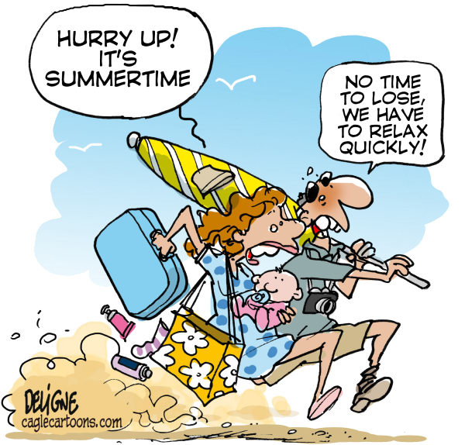

**Helpful tips to save water and money!**

This summer, save a drop. Save a lot. With these simple water conservation tips:

* Watering your lawn for one hour or less, twice a week is sufficient
* For best results, avoid watering during the hottest time of the day or when it’s raining or windy.
* Use sprinklers that throw big drops of water close to the ground. Smaller drops of water and mist often evaporate before reaching your lawn.
* Aerate, compost and weed your lawn to increase moisture retention.
* When mowing, cut the top 1/3 of the grass and leave clippings behind. They are a natural fertilizer and help the soil retain moisture.
* Collect water in a rain barrel and use it to water outdoor plants.
* Instead of washing your car with a running hose, use a bucket and sponge, then rinse using a trigger nozzle on your hose.
* Use a broom instead of a hose to clean your driveway or sidewalk

**To learn more, visit our website: saskwater.com**

**Star City Library Hours**

**Monday – 5:30 pm to 8:30 pm**

**Tuesday – 1:00 pm to 5:30 pm**

**Wednesday – 9:00 am – 1:00 pm**

**Thursday – 1:00pm – 5:30 pm**

[](http://www.google.ca/url?sa=i&rct=j&q=&esrc=s&source=images&cd=&cad=rja&uact=8&ved=0ahUKEwjkmp6wu4nMAhWLSRoKHVOPAYIQjRwIBw&url=http://www.useconference.com/&bvm=bv.119028448,d.ZWU&psig=AFQjCNEGO01ykibVnY8lo2HipmI1aqpBlw&ust=1460562997190122)

**TOWN OFFICE HOURS:** Monday – Friday 8:00 AM – 4:30 PM

CLOSED FROM 12:00 – 12:30 FOR LUNCH

**VISIT OUR WEBSITE @ WWW.TOWNOFSTARCITY.COM**